Bulacan State University

Score:

Time left:

College of Engineering

Computer Engineering Department

CpE 308L – Advance Computer Networks

**Activity No. 3**

**LN, FN, MI: ___________________________________________ Year/Section: ________Date: ___________**

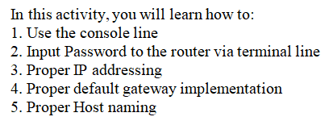

**Please follow the instructions:**

Activity 3: You only have 35 mins to figure this out.

Reopening of this file is STRICLY PROHIBITED.

PART 1

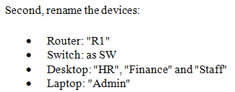

First, place the following devices:

* 1941 Router x 1
* 2960 Switch x1
* Desktop x3
* Laptop x1 (my laptop is not included)

Next, place the IP address: It can be found on one of the computers.

Using CLI in the Router, input their IP address: It can also be found on one of the computers.

Then, connect HR, Finance and Staff via Switches' F0/1, F0/2, F0/3 respectively.

Connect Routers' G0/0 to Switches G0/1 port. Connect Routers’ remaining Gigabit port to Admin.

Lastly, using console cable, connect the Routers Console to Laptops RS 232 port, that should have a blue color.

PART 2

In this part, you will learn how to configure the router via external device (what actually happens when you cofigure a router)

First: open the laptops Terminal

Then on the Terminal Configuration, Simply Click OK.

Next, notice something familiar? You should be able to access the routers CLI

After that, Rename the hostname of the router:

* enable
* config t
* hostname Admin_Router

To put basic security to the system:

* line console 0
* password cisco123
* login
* end
* exit

Now try to login again using the laptops terminal

Now your router cannot be configured (in real life) since it already have a password.

Until this point. you would notice that you still haven't gotten to 100% why?

Try to change the default gateway of the computers based on the IP Address of the router connected (or closest) to them.

You should get a 100 by now.